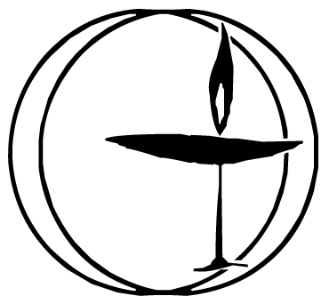
Chalice Circle November 2022
Theme: Ancestry

Opening Words and Chalice Lighting
This light we kindle
is set in the lamp of our history.
We inherit this free faith
from the brave and gentle, fierce and outspoken
hearts and minds that have come before us.
Let us be worthy inheritors of this faith
and through our good works, pass it boldly to a new generation.
- Audette Fulbright Fulson

Song/Youtube link?
https://www.youtube.com/watch?v=dQOaUnSmJr8
Crosby, Stills, Nash & Young - "Teach Your Children" written by Graham Nash (see lyrics on last page)

Reading 1
“All modern humans are related to what scientists call "Mitochondrial Eve." This refers to our common matrilineal ancestor. She lived approximately 200,000 years ago and depending on how you estimate the length of a generation, we are only 5,000 to 10,000 generations from one another. To put it another way, each of us is a cousin of one another at most 10,000 times removed. And yes, Mitochondrial Eve lived in Africa, so, in a very real way, we are all Africans.”
― Desmond Tutu, The Book of Forgiving: The Fourfold Path for Healing Ourselves and Our World

Check-in: Without crosstalk or interruption, briefly describe where you are in your life now, and notice what needs to be shared to be fully present in our circle.

Reading 2
Each generation lives in an illusion of stability. We think that what we cannot imagine cannot happen. We forget that there might be a limit to our imagination, but there is no limit to what we can achieve.
― Dr Prem Jagyasi

Questions to Consider
1. What do you know about your ancestors, where they came from, whether they were saints or sinners?
2. How does your ancestry and/or preceding generations influence who you are?
3. What do you hope the next generation(s) will learn from you?

Sitting in Silence: We will sit in silence for 3-5 minutes. Take this time to reflect on the readings, questions, and theme. Center yourself and consider what you want to share with the group.

Sharing/Deep Listening: Please listen deeply to others & share of your own experience and thoughts on the topic/readings without crosstalk or interruption.

Additional Thoughts/Crosstalk: What questions or additional thoughts do you want to share?
Reading 3
“It is in the roots, not the branches, that a tree’s greatest strength lies.”
― Matshona Dhliwayo

Checkout: How are you feeling now as we leave this circle?

Closing Words/Extinguishing the Chalice
The Chalice is now extinguished,
but its light lives on in the minds and hearts and souls of each one of you.
Carry that flame with you as you leave this place and share it
With those you know
With those you love
and most especially, with those you have yet to meet.
By Brian Kiely

Teach Your Children - Crosby, Stills, Nash & Young
You, who are on the road
Must have a code that you can live by
And so, become yourself
Because the past is just a goodbye

Teach your children well
Their father's hell did slowly go by
And feed them on your dreams
The one they pick's the one you'll know by

Don't you ever ask them, "Why?"
If they told you, you would cry
So just look at them and sigh
And know they love you

And you (Can you hear?) of tender years (And do you care?)
Can't know the fears (And can you see?)
That your elders grew by (We must be free)
And so, please help (To teach your children)
Them with your youth (What you believe in)
They seek the truth (Make a world)
Before they can die (That we can live in)

And teach your parents well
Their children's hell will slowly go by
And feed them on your dreams
The one they pick's the one you'll know by

Don't you ever ask them, "Why?
If they told you, you will cry
So just look at them and sigh
And know they love you

